Department of Artificial Intelligence and Machine Learning
Date: 27/11/2025 | Test – II | Max. Marks: 50
Semester: I | UG | Duration: 1$\frac{1}{2}$ hours
Course Title: AI Foundations for Engineers |  | Course Code: CI114TA

Q. No. | Question | Marks | BT | CO
1.a | A shopping mall parking area is organized as a layered structure:  - Level 0: Entrance  - Level 1: Main Lane  - Level 2: Three Parking Zones (Zone A, Zone B, Zone C)  - Level 3: Four Sub-lanes inside each zone (A1, A2, A3,A4, ….)  - Level 4: Three Individual Parking Slots for Each Sub-lane (A1-1, A1-2, A1-3, ….).  - Represent this as a Graph, with each edge as a valid driving path.  - A driver wants to find the nearest available parking slot from the entrance. Assume only Slot A1-1 is free. Give the BFS approach for this. | 2 + 3 | L3 | CO2
1.b | Depth-first search always expands the deepest node in the frontier first. Apply DFS on the following Graph, assuming the starting vertex as 1.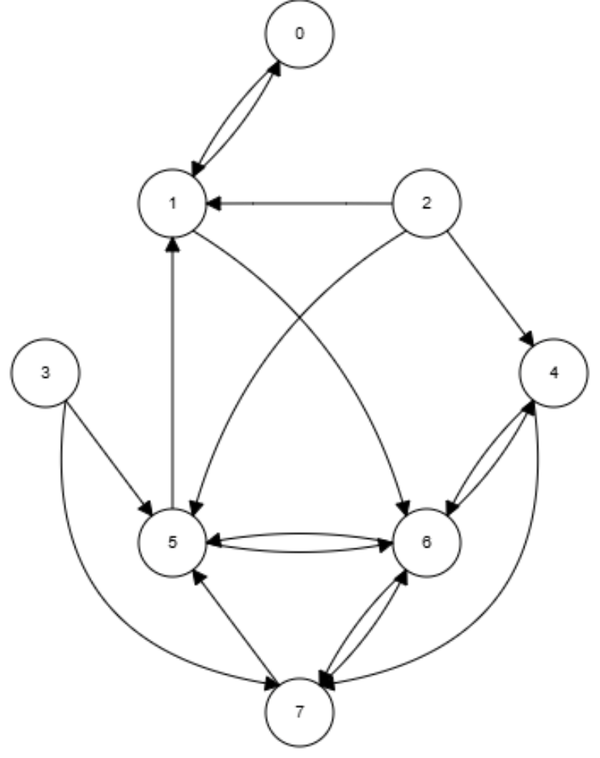 | 5 | L2 | CO2
2 | A robot must navigate a warehouse from Start (S) to Goal (G).  The path costs between nodes are given below:  Edge Cost Table  The Heuristic values (h(n)) for the nodes are as follows: S = 7, A = 6, B = 5, C = 2 and G = 0.  - Using the A* Search algorithm, determine the optimal path from S to G. Show the Frontier and Explored lists, g(n), h(n), f(n) at each iteration.  - Briefly explain the properties of A*: Completeness, Optimality and Admissibility. | 6 + 4 | L3 | CO2
  From | To | Cost
  S | A | 2
  S | B | 4
  A | B | 3
  A | C | 4
  B | C | 6
  C | G | 2
3.a | Using Tom Mitchell’s definition of a well-posed learning problem, specify Task (T), Performance measure (P), and Experience (E) for the following:  - Emotional state recognition using facial images  - Predicting student performance using past academic data | 6 | L3 | CO3
3.b | Define any two of the following issues in Machine Learning:  - Overfitting  - Bias–variance trade-off  - Noise in data  - Curse of dimensionality | 4 | L2 | CO3
4 | Consider the following dataset for predicting Play (Yes/No):  - Compute the entropy of the target attribute Play.  - Compute the Information Gain for the attribute Weather.  Show:  - Entropy of each subset  - Weighted entropy  - Final Info Gain | 5 + 5 | L3 | CO3
  Weather | Wind | Play
  Sunny | Weak | No
  Sunny | Strong | No
  Overcast | Weak | Yes
  Rain | Weak | Yes
  Rain | Strong | No
  Overcast | Strong | Yes
  Rain | Weak | Yes
  Sunny | Weak | Yes
5.a | A startup company is building an email filtering tool.  During model testing, the team observes that the word "offer" appears frequently in spam emails.  The following training statistics were obtained:  A new incoming email contains the word “offer”.  Using the given data, compute the probability that this email is Spam, i.e., calculate 𝑃 (Spam ∣ "offer"). | 5 | L3 | CO3
  Description | Probability
  An email being Spam | 0.25
  An email being Not Spam | 0.75
  The word "offer" appearing in a Spam email | 0.7
  The word "offer" appearing in a Non-Spam email | 0.05
5.b | Explain the working principle of the K-Nearest Neighbours (KNN) algorithm. Illustrate with a simple example (no need to compute distances). | 5 | L2 | CO3

